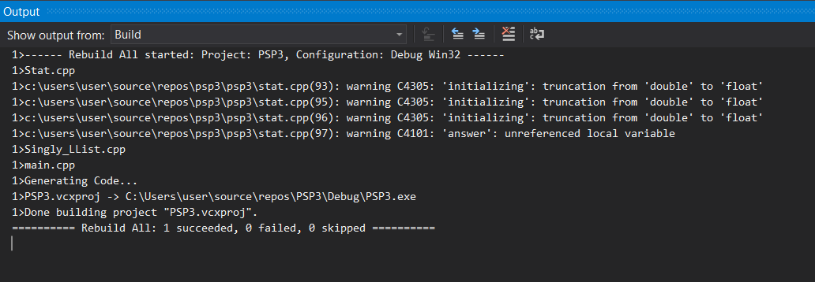

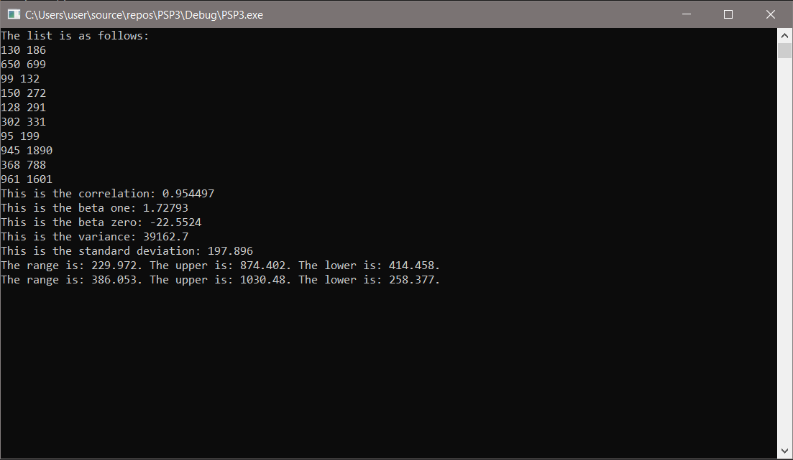

Output Table:

|  |  |  |  |
| --- | --- | --- | --- |
| Test | Parameter | Expected Value | Actual Value |
| Table | Beta Zero | -22.55 | -22.5524 |
|  | Beta One | 1.73 | 1.72793 |
|  | UPI (70%) | 874.4 | 874.402 |
|  | LPI(70%) | 414.46 | 414.458 |
|  | UPI (90%) | 1030.48 | 1030.48 |
|  | LPI(90%) | 258.38 | 258.377 |